Integrating computational tools into foreign policy

|  |
| --- |
| Thomas D. Pike |
| Department of  Computational Social Science |
| George Mason University  4400 University Drive  Fairfax, VA, USA |
| tpike3@gmu.edu |

ABSTRACT

This paper conducts a proof of concept for the integration of computational tools into U.S. foreign policy. Through the application of the bilateral Shapley value, based on a qualitative assessment of Libyan groups, a computational model produces real world agreement with the ongoing civil conflict and explores different policy options. These results provide insights into the situation in Libya as well as possible implications for foreign intervention. This approach shows the potential of computational tools to aid foreign policy decision by exploring the optimal coalition formation of 128 groups and the underlying algorithm can be implemented in one line of code. As the Shapley value is one approach among many, rich libraries of such algorithms may prove invaluable to foreign policy analysis and implementation.

**Keywords:** Libya, Intervention, Policy, Analysis, Intelligence.

# INTRODUCTION

## Concept

Computational tools have the potential to dramatically aid analysts and decision makers as they seek to understand the complexities of foreign populations. Integrating computational tools can allow analysts to leverage highly developed theories as they build models to understand their phenomenon of concern, and experiment with their models to develop richer, more rigorous assessments.

Machine learning libraries such as Scikit-learn and Tensor flow provide a template for how this can be accomplished. Data scientists do not have to rewrite logistic regression equations, principal component analysis or k-means clustering algorithms. Instead, they focus on their data and are able to employ various machine learning tools with a few lines of code through these optimized and tested libraries. The U.S. Government can use the same process to leverage algorithms from the social sciences and apply them to computational models. Currently, however, there is no equivalent rich library ecosystem, like those for machine learning.

This paper conducts a proof of concept by employing a game theoretic algorithm against a foreign policy issue of strategic importance. Specifically, what impact will foreign aid have on coalition formation in the ongoing Libyan civil war?

## Literature Review

Computational models are widely used to study conflict. The U.S. military has employed models to study several aspects of war and even uses simulations to aid in determining force generation and acquisition requirements. In addition, many academics, some sponsored by the military or other parts of the U.S. Government, have used computational models to understand civil conflict. Briefly, there a four major types of computational models, but only two, systems dynamics and agent based models (ABMs) are regularly used for conflict. First and most predominantly there is system dynamics models which look at systems as an indivisible whole (Gilbert and Troitzsch 2005). There is a large number of system dynamics models which extend back to as early as the 1970s (Noton, Mitchell, and Janes 1974) and even the “spaghetti diagram” which was portrayed in popular media as the U.S. strategy in Afghanistan was a systems dynamics model using Stella. ABMs (also known as multi-agent systems, individual based models or entity based models) encode processes in agents. Agents then use these process to make decisions based on their specific situation in their environment (Gilbert and Troitzsch 2005). ABMs are widely used for conflict modelling with Joshua Epstein’s “Modelling Civil Violence” as a notable example of a civil conflict ABM (2002).

Typically, models do not try to describe the whole conflict, instead they look at specific aspects, such as the impact of discriminate or indiscriminate targeting (Bennett 2008; Kress and MacKay 2014), the impact of climate variability and conflict onset (Zinig and Zagorowski 2017) or the impact of aid vs. force (Caulkins et al. 2008; Findley and Young 2007; Pechenkina and Bennett 2017). The process of clearly defining a research question and focusing on specific elements related to the question is an intrinsic step in the modeling (or research) process. This is not only to narrow down the complex phenomenon of civil conflict to a manageable scope, it is also to ensure it is possible to validate the model against the real world. This necessity to narrow is an essential reason why modelling needs to be accessible to more than just experts. Analysts and decisions makers must able to apply models to the specifics of their complex phenomenon as there is not enough experts to provide specific models for each situation’s unique subtleties. Rich libraries of algorithms can enable this customization for analysts and decision makers by providing optimized code and a technological bridge to rigorous theories.

## Overview

In this paper, I argue for the creation of social science modeling libraries by developing a model of how foreign aid may impact coalition formation in the Libyan civil war as a proof of concept. As an underlying algorithm, I use the Shapley value from coalition game theory (Yoav and Leyton-Brown 2009). The Shapley value is one of many possible choices and emphasizes the point that libraries full of different algorithms would allow researchers and analysts greater ability to employ different theories in seeking to understand civil conflict. I chose the Shapley value simply because it has a respected history, is well known (Roth 1988) and is an appropriate tool for understanding how different groups may form alliances in an ongoing conflict.

For modelling, I used Python 3.6 with an ABM construct. I chose an ABM approach for two critical reasons. First, ABMs are able to look at individual or in this case the group level. This allows the analysts and decision maker to see how different groups may react to different policy choices. This provides greater fidelity to the specifics of policy implementation. Second, ABMs are more easily scalable. Agents can be individuals in a village or, as in this model, groups within a nation. It is also possible to link ABMs together to have hierarchies within a model where individual dynamics can feed national group behavior, which in turn produce a national emergent behavior. ABMs provide a more flexible framework which is necessary when dealing with large diverse organizations such as those found in the U.S. Government.

It is important to note, although I use an ABM construct for my model, the Shapley value and coalition game theory in general does not requires ABMs. Coalition game theory is concerned with the combinatorics of coalition formation (Yoav and Leyton-Brown 2009) and with many groups is much more easily employed computationally to explore these possible combinations.

This paper proceeds in four parts. First, a background on the ongoing conflict in Libya and qualitative assessment of groups within Libya. Second, the employment of a specific instantiation of the Shapley value the Bilateral Shapley Value (Ketchpel 1995; Abdollahian, Zinig, and Nelson 2013) to assess coalition formation in Libya. Third, a discussion of the verification of the model, and the results. Fourth, a discussion from two perspectives, (1) the implication of the results from a foreign policy perspective and (2) a discussion of this approach as proof-of-concept.

# Background Libyan Civil war

A basic historical background of Libya’s civil war is necessary to understand the methodology and purpose of this model. The Arab Spring, a series of popular uprisings in Arab countries, began in Tunisia in December 2010 and spread to Libya in February 2011. A popular revolt started against Muammar Gaddafi’s despotic government which had been in place since 1969. Gaddafi responded by trying to violently suppress the uprising. In March 2011, the United Nations voted for a no-fly zone over Libya to protect civilians. The North Atlantic Treaty Organization executed the no-fly zone tipping the balance of power against Gaddafi’s security apparatuses.

By August 2011 Gaddafi’s rule was effectively over as the General National Congress (GNC) took control of the government from the National Transition Council. On October 20, 2011 Gaddafi was captured and then killed. Libya continued the difficult process of forming a new government, only to erupt in a second phase of civil war beginning in 2014. Elections in June 2014 resulted in a defeat from Islamist dominated GNC, who refused to step down. The elected House of Representatives (HoR) tried to assume control of the government resulting in conflict between these two groups. In addition, Islamic Extremists such as Al-Qaeda and the Islamic State had taken or took control of the cities of Sirte, Benghazi and Derna. Through the resulting conflict the HoR fled from Tripoli to Tobruk.

In Janaury 2016, the United Nations tried to broker a peace agreement which produced the Government of National Accord (GNA). The HoR and GNC do not recognize this new government although the international community recognizes it as the official government of Libya. Since 2016 the HoR, allied with General Haftar who commands the Libyan National Army (LNA), made steady progress eastward from Tobruk fighting extremists in Benghazi and Derna as well as securing the major oil revenue pipelines (as shown in Figure 1). The LNA is stopped outside of Sirte, and major push into Sirte would signify the beginning of a conflict between the LNA and the powerful Misratan militias, who seized Sirte from extremists in late 2016.

# Method

## Qualitative Assessment of Libyan Groups

This paper looks at the Libyan civil conflict from the perspective of how foreign support will influence the decision making of the participants as they seek to maximize their situation and shape the emerging order. This approach is consistent with civil wars as highly fluid situations of changing coalitions and local fights, where participants leverage the warring factions for their own ends (Kalyvas 2006).

The challenge is there is little data on how each Libyan perceives the situation and what emergent power structure they may support and under what conditions. As intelligence assessments must use the best information available and infer many details, this qualitative assessment step represents the heavy-lifting required by analysts. Libya has approximately 140 tribes and although Gaddafi tried eliminate the tribes as a part of Libyan identity they still offer a fair representation of the different views of Libyan society (Hatitah and Al-Awsat 2011; Tempelhof and Omar 2012; Masson and Freidel 2012; Eriksson 2016). Based on this information, the tribal level was selected as the appropriate level of analysis..

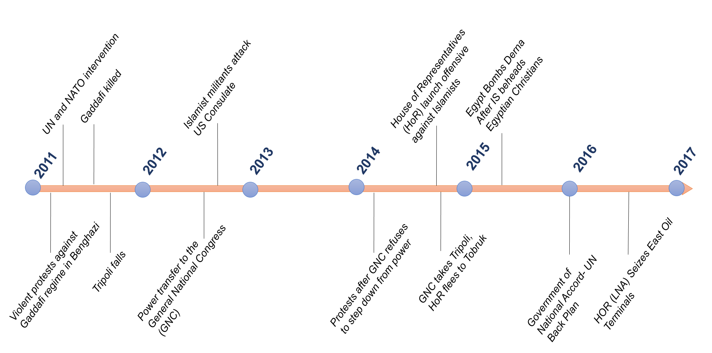

Figure 1: Timeline of events in Libya

(Boduszyński 2015; “Libya Profile - Timeline - BBC News” 2017)

As there is no recent comprehensive study of Libyan tribes, I developed a list of 128 groups through a variety of studies. Several studies described local tribes and their dynamics during the civil war. These studies did allow for a qualitative assessment for several tribes in each of the major regions of Libya (Lacher 2011; Fitzgerald 2015; Eriksson 2016; Boduszyński 2015; Cole and Mangan 2016; Cole and McQuinn 2015). A challenge arose when these tribal groups and their estimated size were compared with population estimates of Libya. There still several areas, particularly in the more densely populated west, for which there was not detailed information. To account for these populations I made inferences based on geographic alignment and historic coalitions. I also accounted for groups of people who are not affiliated with any major tribe and which are aligned with various ideologies in urban centers. (Although never preferred, this need to make inferences based on the best available information is a fundamental part of intelligence analysis.) This process gave me a list of 128 groups who proportionally cover the Libyan population based on the best available information.

Throughout the process of identifying the major tribes, it was also necessary to determine two parameters for the bilateral Shapley value algorithm, preference and power. For preference, this was the group’s ideological affinity. This was assessed using the ubiquitous one dimensional political spectrum prevalent throughout modern politics and dating back to the French revolution (Ferris 2011). Ideological affinity was assessed on a 100 point scale ranging from 0.0 to 10.0. 0.0 represents an ultra-nationalist who is secular and is concerned for the stability of Libya even if another dictator is in charge. 10.0 represents an Islamic extremist, such as those embodied by the Islamic State ideology. Based on the historical background there were three points on this spectrum which are representative of the various competing ideologies. First, an affinity score near 3.0 represents nationalists. Groups who had more secular leanings and generally looked to historical precedent to shape their views of Libya’s future. Second, 6.0 represents fundamentalists. Groups who wanted a more religious society were closer to 6.0, with more fundamentalist groups that followed Salafist traditions (Islamic tradition most closely associated with Saudi Arabia) had higher scores closer to 7 or 8. Islamic extremists, most closely associated with zealots such as Al-Qaeda or the Islamic State had scores at 9 and above.

The average of two variables, economic resources and military capability was used to assess a group’s power. The two variables were selected based on research of political survival and civil war. Groups need economic resources to distribute public and private goods (Bueno De Mesquita et al. 2003) and need a monopoly of force to maintain their power (Weber and Dreijmanis 2008). Economic resources were based on a group’s geographic location and assessed access to major revenue sources also on 100 point scale from 0.0 to 10.0. Qaddafi had a large government which by some estimates employed up to 80% of the population (Elgazzar et al. 2015). Post-Qaddafi Libya has two major revenues sources, trade between Europe and Africa (much of it illicit) and oil (Shaw and Mangan 2014; U.S. Energy Information Administration 2016). An assessment of the group’s access to trade revenue and oil revenue accounting for damaged infrastructure as of spring 2017 formed each group’s economic resources value.

For military capability, I was unable to find detailed descriptions of different militia organizations, military hardware (tanks, planes, etc.) and leadership (ability to leverage these resources and command a following) which would be used for a traditional military assessment. Therefore, each group’s military capability value was assessed based on demonstrated capability and known foreign support. For example, Egypt provided air support to LNA actions against extremists in Derna and generally appears to provide military support to the LNA (“Egypt Launches Strikes in Libya after Minya Attack | Egypt News | Al Jazeera” 2017; “Khalifa Haftar Forces Capture Key Libya Oil Terminals | Libya News | Al Jazeera” 2017). Military capability was also assessed on a similar 100 point scale.

A complete listing of all tribes, their affinity, military capability and economic resources values are located on my github page at <https://github.com/tpike3/Libya-CoalitionFormation>. Due to the challenges of data these assessments can be subject to intense discussion. This then becomes the critical point, analysts regularly must make such assessments in data sparse environments. These assessments are an immense challenge and the focus of much analytic effort. Computational tools, however, can then help analysts test and explore their assessments.

## Computational Model

The computational model has five steps (as shown in Figure 2).

### Agent Instantiation

The first step reads each group from a file and instantiates them as an agent object with the preference and power attributes. Each affinity value is normalized over the range of inputs and stored as the agents original preference value. The military capability and economic resource value are normalized over the range of inputs and then averaged together to form the power value.

### Coalition Formation

Step two of the model is to form coalitions. To do this each agent (A, B) determines the expected utility of forming an alliance with every other agent. The expected utility is calculated:

${v\left(AB\right)= (A}_{power}+B_{power})*ε*(1-\left|A_{affinity}-B_{affinity}\right|)$ (1)

Where ε is the marginal effectiveness parameter and v(AB) is the expected utility of the relationship (Abdollahian, Zinig, and Nelson 2013). The expected utility is then used to calculate the bilateral Shapley value using the following equation:

$BSV\left(A\right)= \frac{1}{2}A_{power}+\frac{1}{2}(v\left(AB\right)-B_{power}$) (2)

Where BSV(A) is the bilateral Shapley value for agent A. If the BSV for both agents is higher than their own power value then the BSV is stored as a potential coalition. After all potential coalitions are assessed then each agent is paired with the best possible coalition and a new agent is formed (Ketchpel 1995).

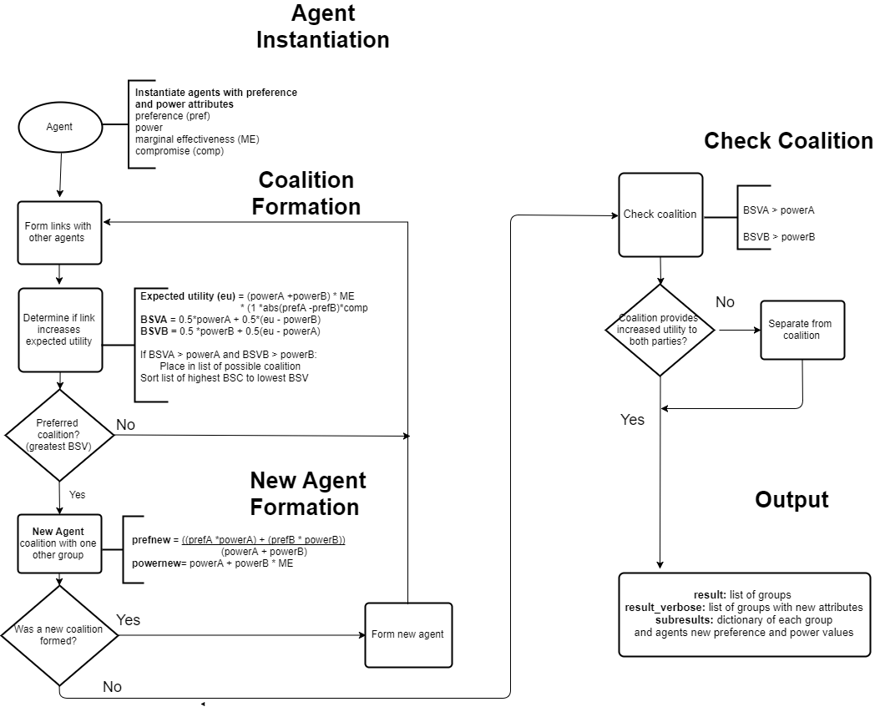

Figure 2: Flow Diagram of Computational Model

### New Agent Formation

Step three forms a new agent based on the pairwise coalition formation. This requires calculating the new agents power and preference attributes. The new agent preference is calculated:

$C_{preference}= \frac{A_{preference}*A_{power}+B_{preference}*B_{power}}{A_{power}+B_{power}}$ (3)

Where C is the new agent which has formed (Abdollahian, Zinig, and Nelson 2013). Joining a coalition influences the preference value of its component parts based on the compromise parameter set in step one. The preference of the agents component agents is updated by:

$A_{preference}={A_{preference}+(C}_{preference}-A_{preference}* γ)$ (4)

Where γ is the inputted compromise parameter determining how much of an affect the new coalition has the group’s affinity values . The new power of this group is:

$C_{power}= {(A}_{power}+B_{power})*ε$ (5)

Where C represents the new agent’s power and ε represents the marginal effectiveness parameter placed in the model. After the new agents form, steps two and three repeat themselves until no new coalitions are formed.

### Check Coalition

In step four each group in the coalition assesses whether they should remain based on the coalition agent’s changing preference and power values as it formed coalitions with more agents. Each agent in the coalition and the coalition as an agent computes their expected utility (1) and their respective BSV (2). If the BSV for the group is higher in the coalition than without it then the group remains. Otherwise, the group removes itself from the coalition and two new agents are formed. The coalition without the group and the group as an agent. The preference and power of the coalition agent is recalculated using equations (3) and (5), while the power of the departing agent reverts to the original input. The preference of the departing agent is not recalculated as civil conflict has shown that impact on ideologies continues to remain even after the conflict has concluded (Malamud-Goti 1996).

### Output

After this final step the model then saves a csv file with all the coalition agents, their power and preference values as well as the agents within these coalitions with their updated preference and values. The code, plus results is available on my github page at <https://github.com/tpike3/Libya-CoalitionFormation>.

# VERIFICATION

To ensure the model was running as programmed I performed two verification procedures. First, I tested each function as it was being built to ensure it behaved as expected and did not produce any errors. Second, I inputted parameters which would produce known results. This included inputting a marginal effectiveness parameter of 1.0 and below. As expected, no agent formed a coalition with any other agent since there was no benefit. Similarly, I inputted a marginal effectiveness parameter above 2.0. The expected result from this input was the formation of a grand coalition which contained all agents (Yoav and Leyton-Brown 2009), and this result was produced.

I also tested the compromise parameter. If the compromise parameter was 1.0, the agents should all adopt the preference of the coalition agent and no agent should defect from the coalition. In addition, if the compromise parameter is 0.0 then no agent should alter their preference and there would be defections. For both values the expected results occurred.

To test the robustness of these verification results I also conducted these tests using generic data over uniform and power law distributions. In each case the expected result was produced.

# Results

The model was run for 450 iterations. 150 runs over varying parameters for three different foreign policy options, (1) no support or intervention, (2) massive support to one nationalist group, (3) support to three groups, nationalist, nationalist-fundamentalist, and fundamentalist. Each of these three policy options was run over the range of parameter inputs.

## Impact of Parameter Variation

The compromise parameter, which determines how far agents will alter their preferences when an agent joins a new coalition, consisted of 10 values ranging from 0.1 to 1.0. The marginal effectiveness parameter, which is the amount of additional benefit gained through forming a coalition, consisted of 15 values ranging 1.1 to 3.0. For the marginal effectiveness parameter 14 of the inputs were between 1.1 and 2.0 with one input at 3.0 to ensure the grand coalition was forming as expected.

The marginal effectiveness parameter had the most impact over a small range of 1.1 to 1.6 with any compromise parameter above 0. 4. A low compromise parameter of less than 0.3 combined with a marginal effectiveness parameter between 1.1 and 1.4 shows the greatest variability both in different numbers of agent formations. The marginal effectiveness parameters of 1.2, 1.3, and 1.4 and compromise parameter of 0.1, 0.2, and 0.3 showed the most variation in the results.

Parameter inputs of 1.1 for marginal effectiveness and 0.1 to 0.3 showed the highest spread of groups with roughly three fringe groups who are non-allied groups on the extreme (> 9.0 or < 1.0) and then two to four medium sized groups spread across the rest of the spectrum. A marginal effectiveness setting of 1.2 and a compromise setting of 0.2 would result in seven fringe groups and three large groups, with a moderate affinity (0.56) as the largest (48) and most powerful (108.84). Increasing the compromise parameter to 0.3 reduced the fringe groups. The reduction of fringe groups by increasing the compromise parameter also occurred with an increase in the marginal effectiveness parameter, indicating that the effect of the compromise parameter was to bring fringe groups into larger coalition formations.

Parameter variation also impacted the preference of the coalition majority. The increase of the marginal effectiveness parameter results in a majority of fundamentalists or nationalists depending on the parameter. At a 1.3 marginal effectiveness parameter, the fundamentalists have the majority and at a 1.4 marginal effectiveness parameter the nationalists have a majority. Based on these result additional run at value of 1.35 and 1.45 where conducted. The nationalist only obtained a majority at 1.4 losing it again at 1.45. By 1.5, a near grand coalition was reached where the ideology was centrist at a 0.56 preference and all but the fringe groups were part of the coalition (as shown in Figure 3). Runs at 1.25 and runs at 1.55 showed no significant change. These results are all under conditions of no new foreign support.

## Impact of Foreign Support

The goal of this model was to gain a better understanding of how the different groups in Libya may coalesce to assess how the civil war may develop. It was also to assess how foreign intervention may affect how the groups coalesce. In addition to the no support policy option, two additional policy options were assessed. First, substantial aid to one nationalist group in an effort to combat extremism taking over Libya. Using Afghanistan as a rough metric, according to the world bank the Afghanistan GDP in 2011 (the peak of U.S. support) was 17.93 billion dollars. U.S. foreign aid provided was 13 billion dollars (USAID 2017). This does not include military support which is harder to measure quantitatively. Based on this metric, however, it is clear that a substantial influx for U.S. foreign support represents a substantial amount of power investment. To replicate this overwhelming advantage. the supported group (al-Udbaidat), the most powerful nationalist group received an economic and military boost to 99.0.

Examining the impact of foreign support to one group shows that the support group has less incentive to form a coalition and that more groups support a more fundamentalist coalition. Increasing the compromise parameter continues to reduce the number of fringe groups, while a marginal effectiveness parameter of 1.1 increases the size of the non-supported moderate large coalition (preference 0.54) from 37 to a coalition of 45 groups (preference .55) while the supported group (preference .33) only increases by 1 to 25 (preference 0.3). As the marginal effectiveness parameters increases to 1.3, the 0.32 preference coalition (supported group) goes from 30 to 49 (new affinity of 0.34), while the 0.65 affinity coalitions goes down from 87 to 67 (new affinity of 0.69). Interestingly, the impact of foreign support at a marginal effectiveness of 1.4 is to cause a more fundamentalist leaning affinity to gain a majority which they did not gain in the non-supported model run. The 0.49 affinity coalition (supported coalition) went from an 83 group coalition to a 29 group coalition with a new affinity of (0.3) while the more Islamic extreme affinity coalition went from a 0.81 affinity and a 37 group coalition to 0.65 affinity and a 90 group coalition. Support to one group caused the group to be more powerful, but also made them less willing to form a coalition with other groups, which also prevented their preference form moderating.

The impact of foreign support to three groups as a policy option, resulted in no difference than the no support option, except the specific agents who received support made their agent coalition more powerful. As the model does not account how these different power dynamics may influence the outcome, there is nothing additional to report about these results.

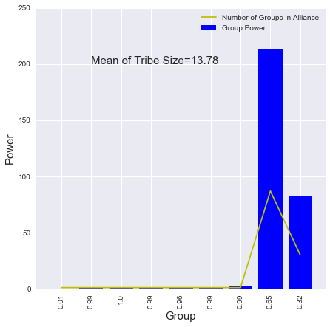 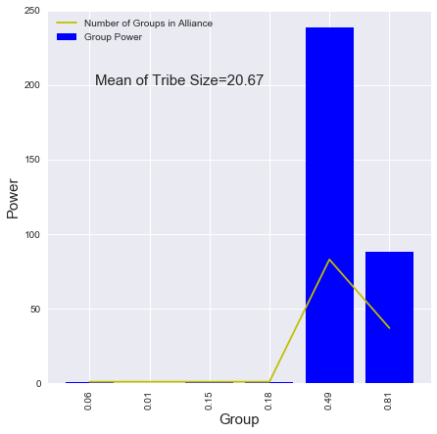

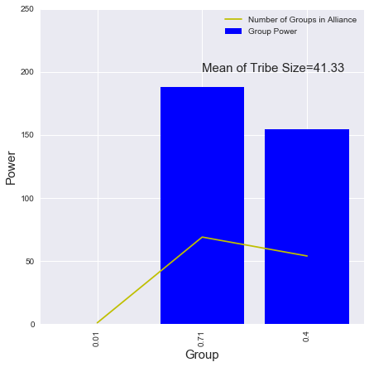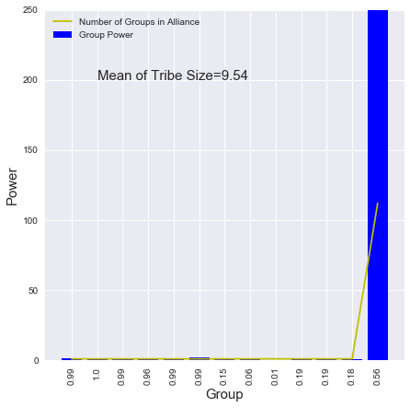

Figure 3: Impact on the majority agent preference (ideology) with a compromise parameter of 0.1 and varying marginal effectiveness parameters. (top left) Marginal effectiveness of 1.3, more fundamentalist majority - 0.65 preference. (top right) Marginal effectiveness of 1.4, more moderate majority - 0.49 preference. (bottom left) Marginal effectiveness of 1.45, more fundamentalist majority - 0.71 preference. (bottom right) Marginal effectiveness of 1.5, moderate majority, near grand coalition - 0.56 preference.

# Discussion

## Validation

The specifics of the Libyan coalitions produced by the model show simplistic agreement with known Libyan coalitions. In Tobruk, Sa’ada tribes (which includes the al-Ubaidat) have an coalition with the Murabitin tribes (which includes Qunashat, Habun, Qutan and Mnaffa). These coalitions are replicated in the model as these groups align under the discussed input parameters. The reason the model shows simplistic agreement is because in reality the coalition is tense and requires very complex mechanisms to maintain the coalition which the model is unable to replicate (Kane 2015).

In Sabha, the model shows coalitions with Awlad Sulaiman and Masrata tribes. The Tuareq who are active in the trading networks ally with the more moderate majority, which is consistent with their role as an ethnic minority, who will opportunistically ally to serve their own purposes (Cole and Mangan 2016).

The story for Bani Walid is more complex. The town is made up of five Warfalla sub-tribes (Sa’dat, Jmamla, Sabayi and 2 Mtarfa tribes). Internally, the Mtarfa feel like an oppressed minority who tried to take control of Bani Walid by aligning with Islamists after Gaddafi’s fall. Bani Walid as a city, however, was punished by Gaddafi for decades as it was seen as the origin of a failed coup in the 1990s. This made the dominate three tribes unwilling to rebel in 2011 and they have tried to keep their city out of the civil war after retaking the town from the Mtarfa and more extreme Islamic groups (Cole and Mangan 2016; Cole 2015). The model cannot capture these complex dynamics but it does show the Mtarfa aligning with fundamentalists coalitions while the Sa’dat, Jmala, and Sabayi align with more moderate nationalist or fundamentalist configurations.

In addition, the model is able to produce extremists groups who do not ally with each other or Islamist groups. This is consistent with the role extremists have played, often being attacked by fundamentalist and driven from their strongholds as happened in Sirte which was taken by Misratan militias.

Although the model cannot replicate the complex mechanisms of tribal arbitration and rich local histories, it does replicate agreement with known coalitions in Libya.

## Implications for Libya Policy

The impact of foreign aid to one major group (al-Ubaidat) stylistically agrees with macro-level experiences in Afghanistan, where financial and military aid to a specific group makes them more powerful, but can decrease the number of groups with whom they are incentivized ally while increasing the number of groups in an adversarial coalition (Kilcullen 2010). This model shows such a policy may be counterproductive by making a minority coalition against whom a majority coalition forms.

The model also demonstrates the most effective policy may not be increasing a group’s power, but instead increasing their marginal effectiveness. This recommendation agrees with the civil conflict literature (Kalyvas 2006; Galula 2006; Kilcullen 2010), but presents challenges for practical implmentation.

## Potential as Analyst Tool

This approach fundamentally alters the historic Westphalian perspective of a foreign country as a homogenous entity. By examining how 128 different groups may react to a large influx of outside support this model assumed a fundamentally different perspective in which foreign actions influence the inner workings, decisions and evolution of the foreign population. Computing the optimal coalitions of 128 groups all examining every other possibility as each new coalition changes their options is a non-trivial task which is possible through the aid of computation. As this model can take different numbers of groups, from any population, in any time period to explore, the model offers much greater flexibility in analyzing how coalitions within a population form and what aspects of the various groups affected those coalitions. This approach offers significant new possibilities in which to explore the impact of foreign support.

In addition, the algorithm can be implemented in one line of code. Currently, this variation can be found at <https://github.com/tpike3/mesa>, while it undergoes consideration for inclusion in the Python based ABM library Mesa. With this variation, any analyst can quickly and easily implement it in an ABM. If other algorithms from social science were also readily accessible then analysts could combine them to create richer models able to explore a wider variety of phenomenon. For example, the use of the Bilateral Shapley value and conflict onset theory were combined to explore the impact of climate variability and civil conflict (Zinig and Zagorowski 2017). This use of the model then makes it identical to parametric machine learning algorithms in wide spread use today.

## Future Research

Diversifying the marginal effectiveness parameter so different groups have different attributes and whose coupling have different impacts would be a potentially powerful way to extend this model. For example, a Misrata tribe may form an coalition with an Awlad Sulaiman tribe in Sabha to create a trade route to move goods from Europe into Africa and vice versa. This coalition would have more marginal effectiveness than the Misrata tribe forming an coalition with a tribe from Al-Khums another coastal city near Misrata. This approach also provides the possibility of seeing what impact improving a specific group’s attributes may have on coalition formation. This may result in more specific foreign aid policies which have the ability to grow bottom up solutions instead of broad top down foreign policy interventions.

The broader area for future research is the development of rich social science libraries, which allows analysts, researchers or whomever to develop models for specific phenomenon of interest. The world of machine learning as already shown the power of such an approach.

# Conclusion

The application of a computational model to Libya’s ongoing civil conflict has demonstrated the potential of such tools for intelligence analysis. This model using the well-known Shapley value from coalition game theory produced results consistent with observed phenomenon in the conflict, as well as results consistent with other foreign interventions.

The model was able to go beyond human cognitive capability by analyzing the potential combinations of 128 groups. The underlying algorithm, the bilateral Shapley value, was also optimized to be implemented in one line of code. These results validate the proof of concept.

The development of a rich ecosystem of social science algorithms which can be easily employed by researchers, analysts or any other interested individual has the potential to revolutionize how we understood and engage the world.

# AUTHOR BIOGRAPHy

**THOMAS D. PIKE** is a PhD student at George Mason University in the Department of Computational Social Science. He is an active duty Lieutenant Colonel in the U.S. Army, serving as a Strategic Intelligence officer. The views expressed in this paper are his own and do not reflect those of the U.S. Government Department of Defense or U.S. Army. His email address is [tpike3@gmu.edu](mailto:tpike3@gmu.edu).

# references

Abdollahian, Mark, Yang Zinig, and Hal Nelson. 2013. “Techno-Social Energy Infrastructure Siting : Sustainable Energy Modeling Programming ( SEMPro ).” *Journal of Artifical Socieities and Simulation* 16 (3): 1–12.

Bennett, D. Scott. 2008. “Governments, Civilians, and the Evolution of Insurgency: Modeling the Early Dynamics of Insurgencies.” *Jasss* 11 (4).

Boduszyński, Mieczysław P. 2015. “The Libyan Revolution and Its Aftermath / The 2011 Libyan Uprisings and the Struggle for the Post-Qadhafi Future.” *The Journal of North African Studies* 20 (5): 898–900. doi:10.1080/13629387.2015.1075307.

Bueno De Mesquita, Bruce, Alastair Smith, Randolph M. Siverson, and James D. Morrow. 2003. *The Logic of Political Survival*. Cambridge, Massachusetts: The MIT Press.

Caulkins, Jonathan P., Dieter Grass, Gustav Feichtinger, and Gernot Tragler. 2008. “Optimizing Counter-Terror Operations: Should One Fight Fire With ‘fire’ or ‘water’?” *Computers and Operations Research* 35 (6): 1874–85. doi:10.1016/j.cor.2006.09.017.

Epstein, J. M. 2002. “Modeling Civil Violence: An Agent-Based Computational Approach.” *Proceedings of the National Academy of Sciences* 99 (Supplement 3): 7243–50. doi:10.1073/pnas.092080199.

Ferris, Timothy. 2011. *The Science of Liberty: Democracy, Reasons and the Laws of Nature*. New York: Harper Perennial.

Findley, Michael G., and Joseph K. Young. 2007. “Fighting Fire with Fire? How (Not) to Neutralize an Insurgency.” *Civil Wars* 9 (4): 378–401. doi:10.1080/13698240701699482.

Galula, David. 2006. *Counterinsurgency Warfare: Theory and Practice*. 2nd ed. Westport, Connecticut: Praeger Security International. doi:0-275-99269-1.

Gilbert, Nigel, and K G Troitzsch. 2005. *Simulation for the Social Scientist*. *Statistics*.

Kalyvas, Stathis N. 2006. *The Logic of Violence in Civil War*. New York: Cambridge University Press.

Ketchpel, S P. 1995. “Coalition Formation among Autonomous Agents.” *From Reaction to Cognition*, no. 957: 73–88.

Kilcullen, David. 2010. *Counterinsurgency*. Oxford: Oxford University Press.

Kress, Moshe, and Niall J. MacKay. 2014. “Bits or Shots in Combat? The Generalized Deitchman Model of Guerrilla Warfare.” *Operations Research Letters* 42 (1). Elsevier B.V.: 102–8. doi:10.1016/j.orl.2013.08.004.

“Libya Profile - Timeline - BBC News.” 2017. Accessed May 8. http://www.bbc.com/news/world-africa-13755445.

Malamud-Goti, Jaime. 1996. *Game Without End: State Terror and the Politics of Justice*. Norman, Oklahoma: Oklahoma University Press.

Noton, M., C. R. Mitchell, and F. R. Janes. 1974. “The Systems Analysis of Conflict.” *Futures* 6 (2): 114–32. doi:10.1016/0016-3287(74)90018-4.

Pechenkina, Anna O, and D Scott Bennett. 2017. “Violent and Non-Violent Strategies of Counterinsurgency Two Broad Approaches to Counterinsurgency.” *The Journal of Artifical Societies and Social Simulations* 20 (4). http://jasss.soc.surrey.ac.uk/20/4/11.html.

Roth, Alvin E. 1988. *The Shapley Value*. *Game Theory and Applications*. doi:10.1017/CBO9780511528446.

USAID. 2017. “U.S. Foreign Aid by Country.” Accessed November 11. https://explorer.usaid.gov/cd/AFG.

Weber, Max, and John Dreijmanis. 2008. *Max Weber’s Complete Writings on Academic and Political Vocations*. New York: Algora Publishing. http://search.ebscohost.com/login.aspx?direct=true&db=nlebk&AN=221042&site=bsi-live.

Yoav, Shoham, and Kevin Leyton-Brown. 2009. *Multiagent Systems: Algorithmic, Game-Theoretic, and Logical Foundations*. Kindle. New York: Cambridge University Press.

Zinig, Yang, and Piotr Zagorowski. 2017. “Climate Variability, Opposition Group Formation and Conflict Onset.” In *Advances in Applied Digital Human Modeling and Simulation: Proceedings of the AHFE 2016 International Conference on Digital Human Modeling and Simulation*, edited by Vincent G. Duffy, 183–91. Springer.